Proposal Content – Engen Supply
- Organisation Overview
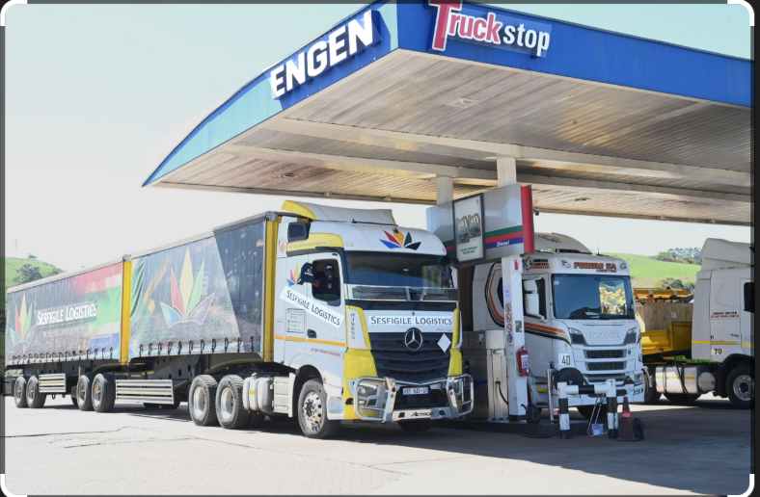
Name: Engen Fuel Supply Services
Brief History:
Engen is one of Africa’s leading oil companies, providing fuel, lubricants, and convenience services. The company helps people to get to their destinations freely without worrying about anything.
Mission Statement:
To provide reliable, high-quality fuel and energy to all the countries out there .
Vision Statement:
To be the leading and most trusted fuel supplier in Africa .
Target Audience:
- Transport companies
- Logistics businesses
- Mining companies
- People with cars

2. Website Goals and Objectives
Main Goals:
- Increase online visibility of Engen fuel supply services.
- Provide information about fuel products and supply options.
- To help people to arrive at their destinations with no disturbances
Key Performance Indicators (KPIs):
- Increase website traffic by 30%.
- Increase fuel supply enquiries through the website.
3. Current Website Analysis (if applicable)
Strengths:
- Strong brand recognition.
- Informative content about products and services.
- Established customer trust.
Weaknesses:
- Navigation can be improved.
- Some information is difficult to find.
- Mobile experience could be improved.
Areas for Improvement:
- Faster page loading speed.
- Clearer service and product descriptions.
- Improved mobile-friendly design.
4. Proposed Website Features and Functionality
The website will include the following key pages:
Homepage
- Overview of Engen fuel supply services
- Featured products
- Quick links to services
About Us
- Company history
- Mission and vision
- Corporate values
Products / Services
- Fuel supply
- Bulk fuel delivery
- Lubricants
Service Station Locator
- Interactive map to find nearby Engen stations
Request a Quote
- Online form for businesses needing fuel supply
Contact Page
- Phone number
- Email

5.Design and User Experience
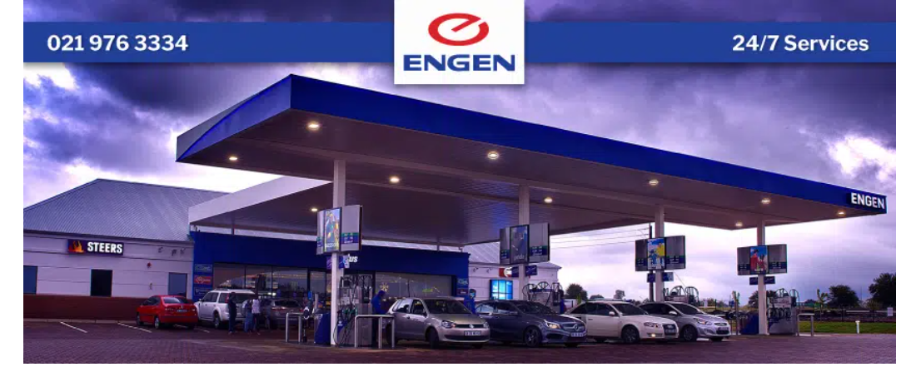
Overall Design Aesthetic
The website will have a modern, clean, and professional design reflecting Engen’s brand identity.
Colour Scheme
The design will use the brand colours of Engen Petroleum:
- Blue – Trust and professionalism
- Red – Energy and strength
- White – Clean and simple layout
Typography
- Headings: Montserrat Bold
- Subheadings: Montserrat Medium
- Body Text: Open Sans
User Experience Considerations
To ensure ease of use:
- Simple navigation menu
- Clear service categories
Typography (Font Choices and Hierarchy)
Choose fonts that look professional, modern, and easy to read.
Example:
- Headings: Montserrat Bold – for strong titles.
- Subheadings: Montserrat Semi-Bold.
- Body text: Open Sans or Roboto – easy to read on websites.
- Hierarchy Example:
  - H1: Page Title (e.g., Engen Fuel Supply Solutions)
  - H2: Section titles (Services, Products, Locations)
  - Body: Descriptions and information.

Layout and Design (Overall Design Approach)
Design Style:
- Clean corporate design
- Use Engen colours (blue, red, white)
Suggested Layout Structure:
Homepage
- About Engen Supply
- Services section
- Locations / Delivery areas
- Contact form
Navigation Menu
- Home
- About
- Fuel Products
- Service Stations
- Contact

User Experience (UX)
To make the site easy for users:
Navigation
- Clear buttons (Request Fuel Quote)
Colour Scheme
- Blue
- Red
- White background
User-friendly features
- Fuel price updates
- Service station locator

Low-Fidelity Wireframe Idea
Homepage Wireframe
6. Technical Requirements
Domain Name
- www.engensupply.co.za
Hosting
- Well host for Engen supply
Programming Languages
- HTML (structure)
- CSS (design)
- JavaScript (interactive features)
Frameworks / Tools
- Bootstrap (responsive design)
- Google Maps API (station locator)

7. Timeline and Milestones
Example 4-week plan:
Week | Task
Week 1 | Research Engen supply services + website planning
Week 2 | Design layout and wireframes
Week 3 | Develop HTML, CSS, and pages
Week 4 | Testing, improvements, and submission

8. Budget (Example Estimate)
Item | Estimated Cost
Domain Name | R200 / year
Web Hosting | R1000 / year
Website Development | R6000
Maintenance | R1000
Total Estimate | R8 200

9. Refences
https://www.engen.co.za/about/supply-and-distribution
Engen supply company
Fuel sells company for the Engen
https://www.engen.co.za/

